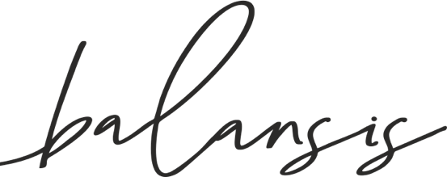



**https://balansis.pl**



https://balansis.pl

•

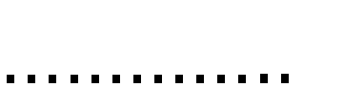

•



•











zwroty@balansis.pl

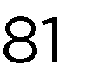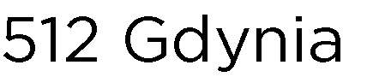

Balansis Cosmetics

Mickiewicza 37/58

01- 625

Warszawa

